**Project 1: Sales Performance Analysis**

**Project Title:** Sales Performance Analysis Dashboard

**Objective:** To analyze and visualize sales performance using Python for data processing, SQL for database queries, and Power BI for interactive dashboards.

**Steps:**

1. Use SQL to extract sales data from a relational database.
2. Use Python (Pandas) to clean and preprocess the data.
3. Write SQL queries to aggregate sales data by region, product, and time period.
4. Load the cleaned and aggregated data into Power BI.
5. Create visualizations such as bar charts, line graphs, and pie charts in Power BI.
6. Add filters and slicers to the dashboard for interactive analysis.

**Expected Outcome:** An interactive dashboard providing insights into sales trends, performance by region/product, and overall sales metrics.

Task 1:

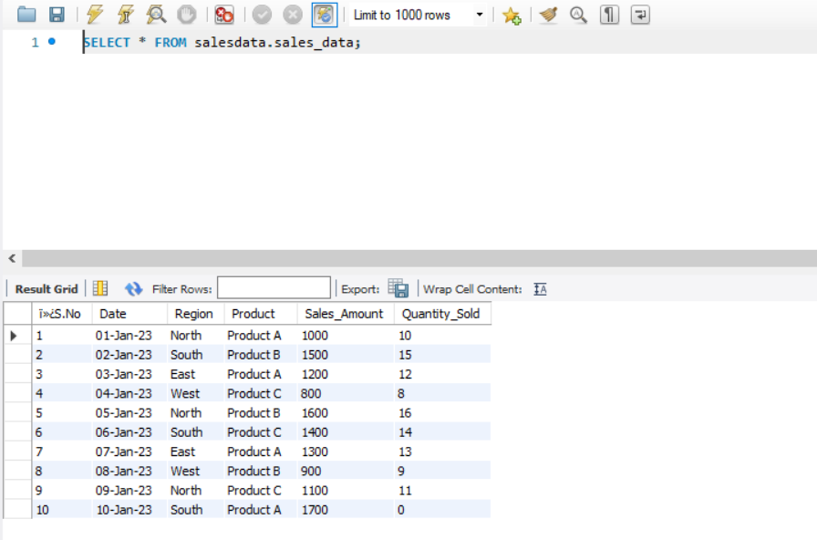

Task 2: Python codes

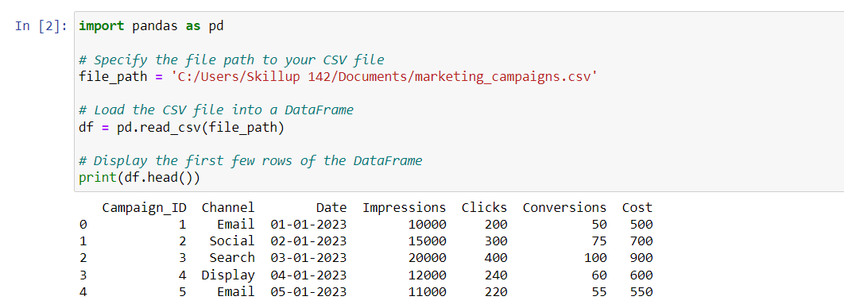

Power Bi Dashboards

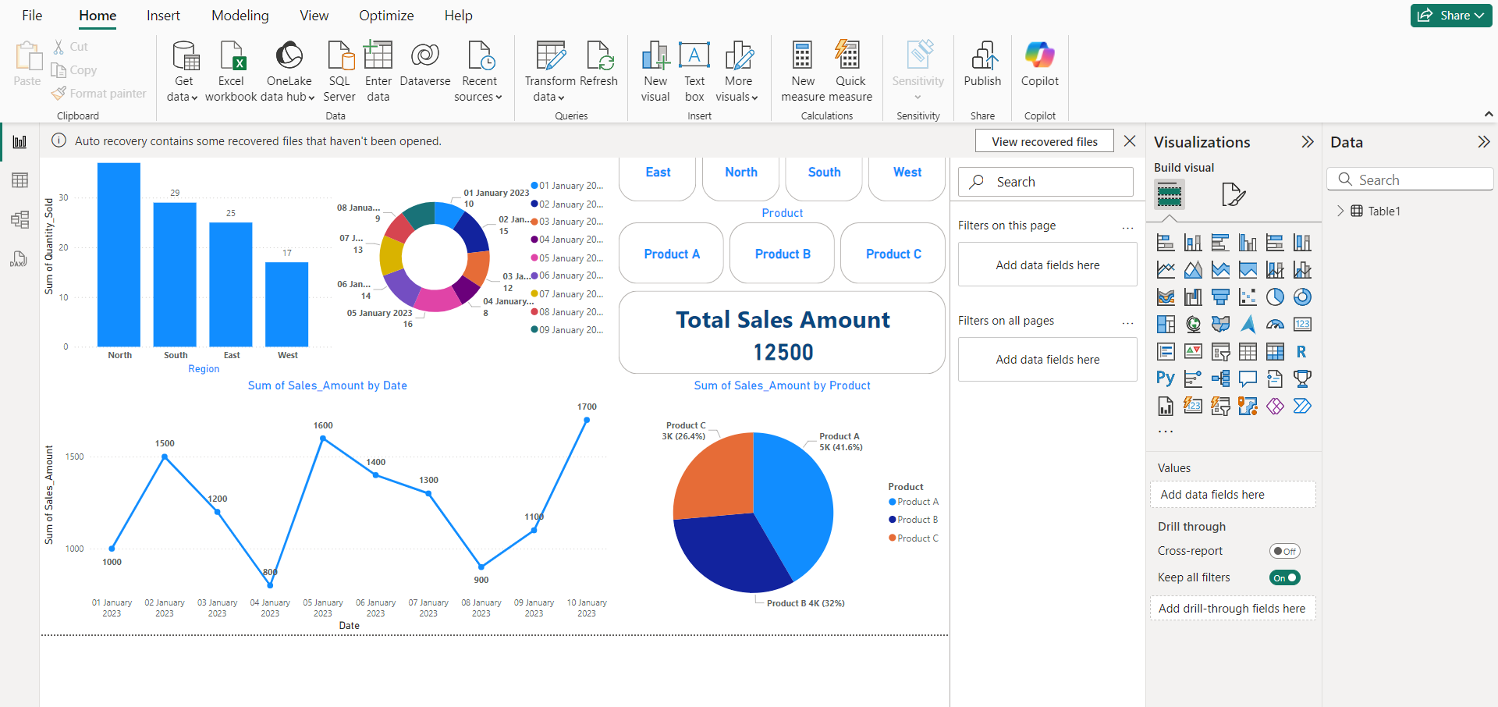

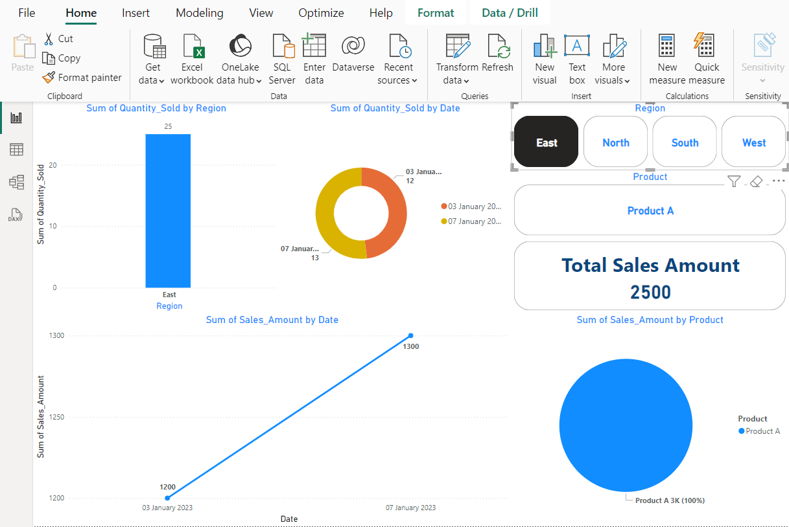

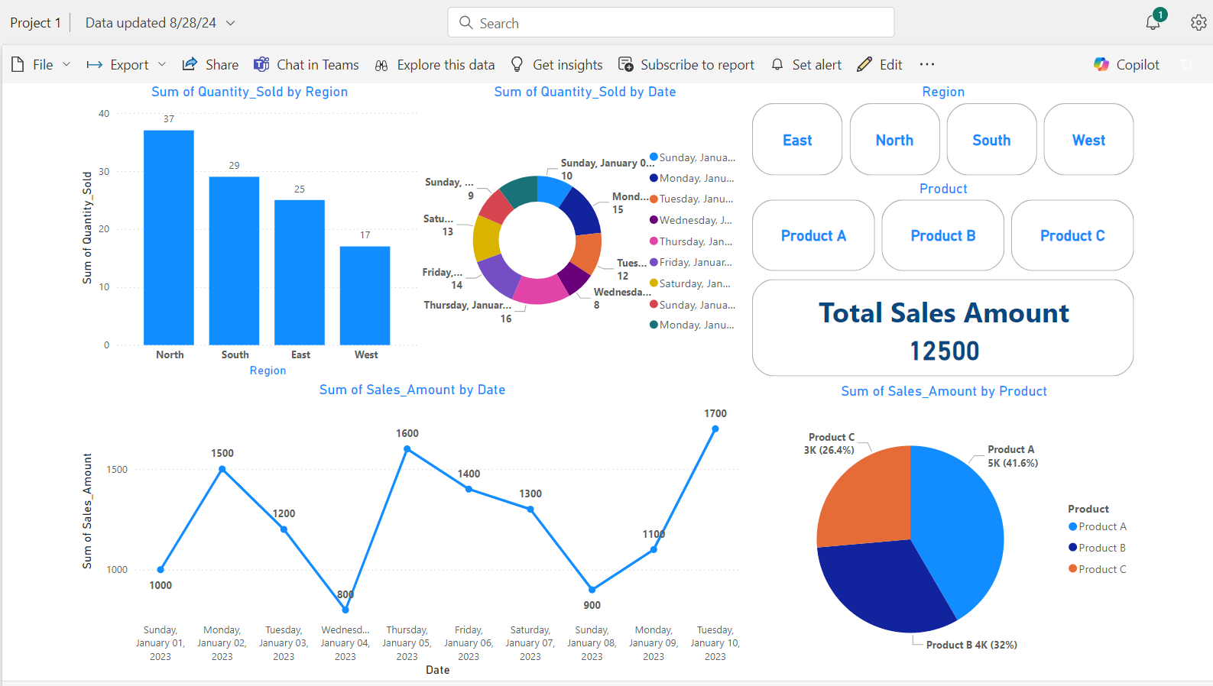

Power BI Dashboard link: <https://skilluptech-my.sharepoint.com/:u:/g/personal/gouravs_skillup_online/ETgs8d9VVoJPt1R4I61Sf7sBvkF2ndzzuMXiHuX_B9QoMg?e=OiRxJV>